SEMESTER TWO
Papers written by
Australian Maths Software

YEAR 11

MATHEMATICS METHODS
Units 1 & 2
REVISION 2
2016

Section One
(Calculator–free)

Name: _________________________________

Teacher: ________________________________

TIME ALLOWED FOR THIS SECTION

Reading time before commencing work: 5 minutes
Working time for section: 50 minutes

MATERIAL REQUIRED / RECOMMENDED FOR THIS SECTION

To be provided by the candidate
Standard items: pens, pencils, pencil sharpener, highlighter, eraser, ruler.

IMPORTANT NOTE TO CANDIDATES
No other items may be taken into the examination room. It is your responsibility to ensure that you do not have any unauthorised notes or other items of a non–personal nature in the examination room. If you have any unauthorised material with you, hand it to the supervisor before reading any further.

To be provided by the supervisor
Question/answer booklet for Section One.
A formula sheet which may also be used for Section Two.
Structure of this examination

 | Number of questions available | Number of questions to be answered | Working time (minutes) | Marks available | Percentage of exam
Section One  Calculator—free | 7 | 7 | 50 | 52 | 35
Section Two  Calculator—assumed | 11 | 11 | 100 | 98 | 65
Total marks |  |  |  | 150

Instructions to candidates

1. The rules for the conduct of this examination are detailed in the Information Handbook.
Sitting this examination implies that you agree to abide by these rules.

2. Write your answer in the Question/Answer booklet.

3. You must be careful to confine your responses to the specific questions asked and to
follow any instructions that are specific to a particular question.

4. Spare pages are provided at the end of this booklet. If you need to use them, indicate
in the original answer space where the answer is continued i.e. give the page number.

5. Show all your working clearly. Your working should be in sufficient detail to allow your
answers to be checked readily and for marks to be awarded for reasoning. Incorrect
answers given without supporting reasoning cannot be allocated any marks. For any
question or part question worth more than two marks, valid working or justification is
required to receive full marks. If you repeat an answer to any question, ensure that you
cancel the answer you do not wish to have marked.

6. It is recommended that you do not use pencil, except in diagrams.

7. The Formula Sheet is not to be handed in with your Question/Answer booklet.

Section One: Calculator–free 52 marks

This section has six (6) questions. Attempt all questions.
Working time: 50 minutes

Question 1 (6 marks)

Complete the following

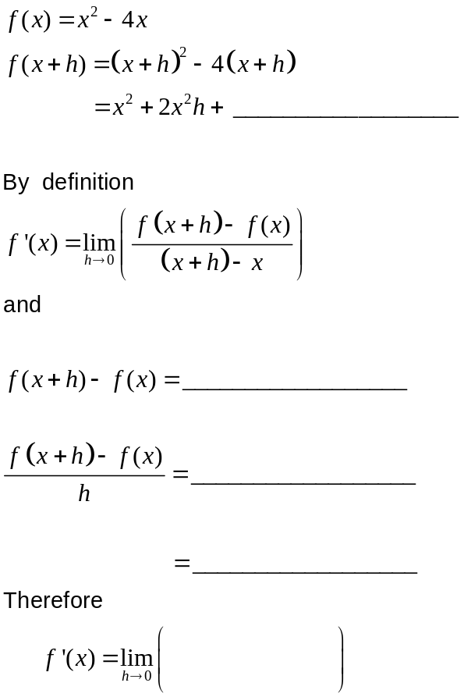

∴ 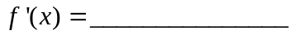
(6)

Question 2 (7 marks)

(a) Given 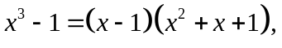 prove algebraically that there is only one solution to the equation 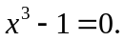 (2)

(b) Sketch the relations
(i) 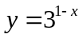 (ii) 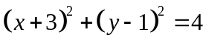 (3+2)
on the sets of axes below.

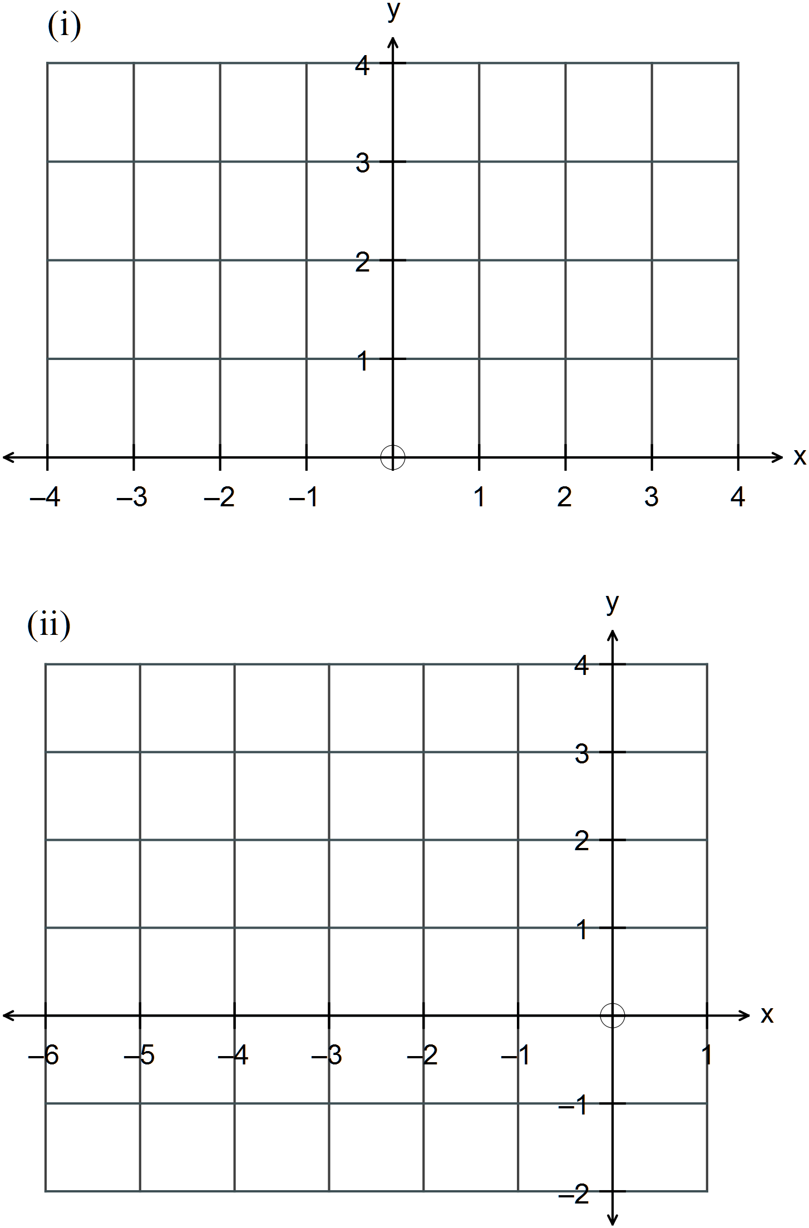
Question 3 (9 marks)
(a) Simplify 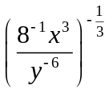 (3)

(b) Simplify 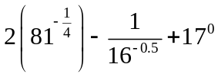 (3)

(c) Solve 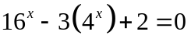 (3)
Question 4 (13 marks)

(a) Giventhe first four terms of a sequence 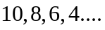,
(i) write down the rule for the sequence in terms of (2)

(ii) write the recursive rule that describes the sequence. (2)

(b) Given 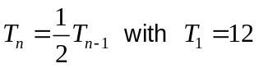, rewrite the expression in terms of . (2)

(c) A tree grew to 2 metres in the first year. Every year the tree grew one half of what it
grew the previous year.

How tall does the tree grow? (3)

(d) In how many ways can a basketball team of 5 players be selected from 8 boys

(i) if all boys are available? (2)

(ii) if one boy has broken his ankle and another is moving to another city so neither of them can play? (2)


Question 5 (8 marks)

Consider the points with coordinates P(-1, 2), Q(3, 1), R(4, 5) and S(x, y) as in the diagram below.
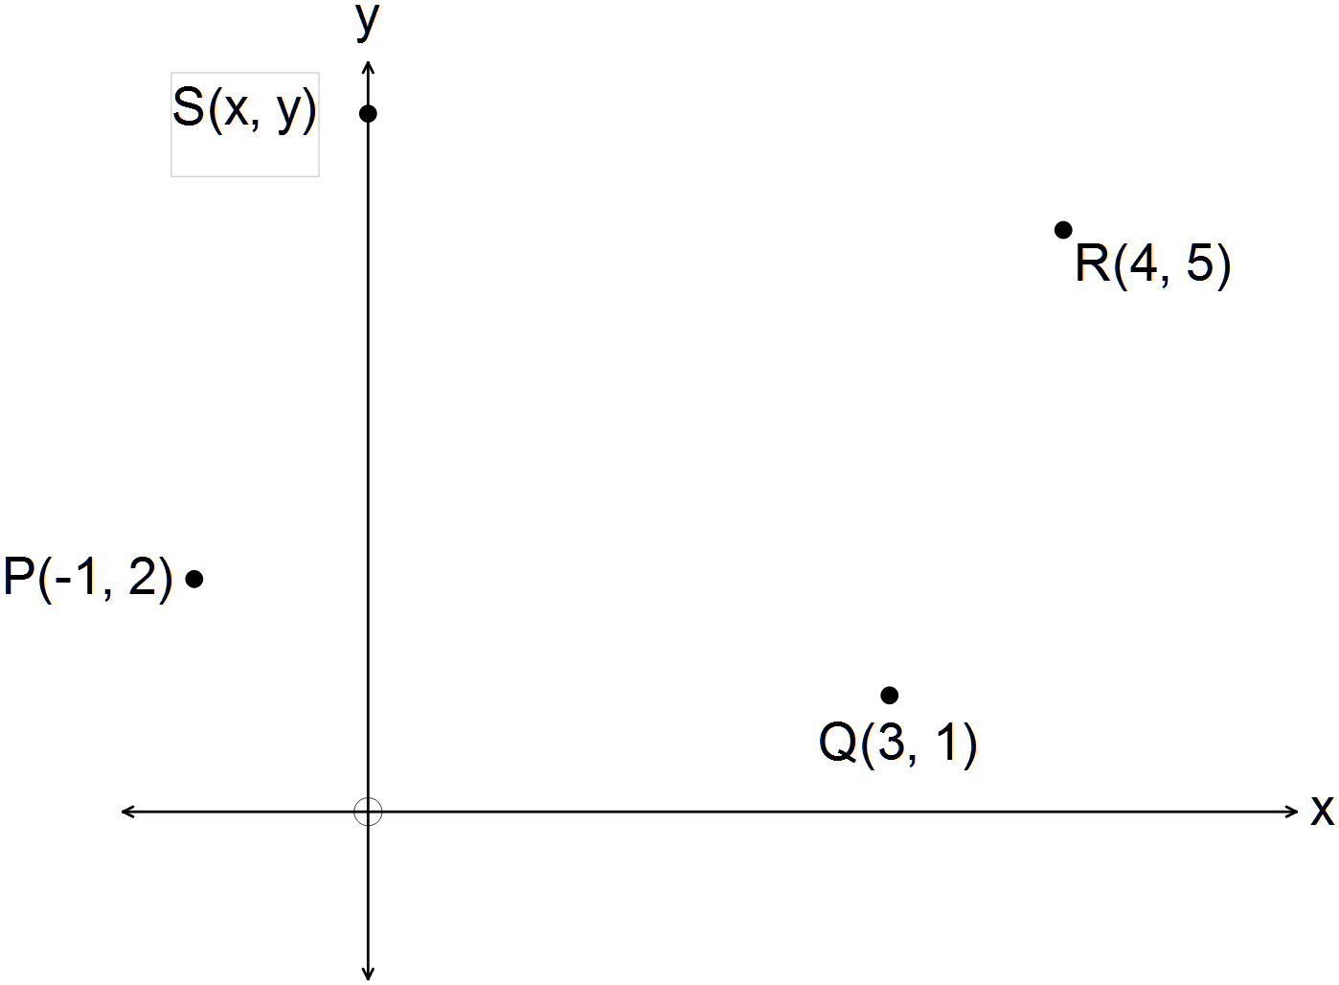

(a) Determine if

(i) PQ is perpendicular to QR. (2)

(ii) PQ = QR (2)

(b) Find the coordinates of S if PQRS is a parallelogram. (2)

(c) Show that the diagonals of this parallelogram bisect each other. (2)

Question 6 (6 marks)

(a) The number of amoeba in a petri dish doubles every minute.
If there are 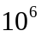 amoeba in the dish at 10.20 a.m., write down an expression for the
number in the dish at

(i) 10.24 a.m. (2)

(ii) 10.17 a.m. (2)

At what time will the number be equal to

(iii) 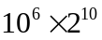 ? (2)

Question 7 (3 marks)

Determine
(a) 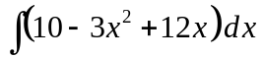 (1)

(b) 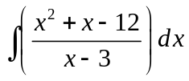 (2)

END OF SECTION ONE

